Exp 15: Create a Snapshot of a VM and Test it by loading the Previous Version/Cloned VM using Vmware workstation.
Aim
Capture a point-in-time state of a VM and test recovery by reverting to the snapshot..
Procedure
- Boot the VM to a clean baseline (all apps closed).
- VM → Snapshot → Take Snapshot… → name it (e.g., “Baseline-1”) with a brief description.
- Make some changes (install/update an app or edit files) to simulate drift.
- VM → Snapshot → Snapshot Manager → select Baseline-1.
- Click Go To (or Revert) to load the previous state.
- After revert, verify the pre-change state (apps uninstalled, files rolled back).
Output
Figure 1 Virtual Machine with 1 CPU, 2 GB RAM, and 15 GB storage
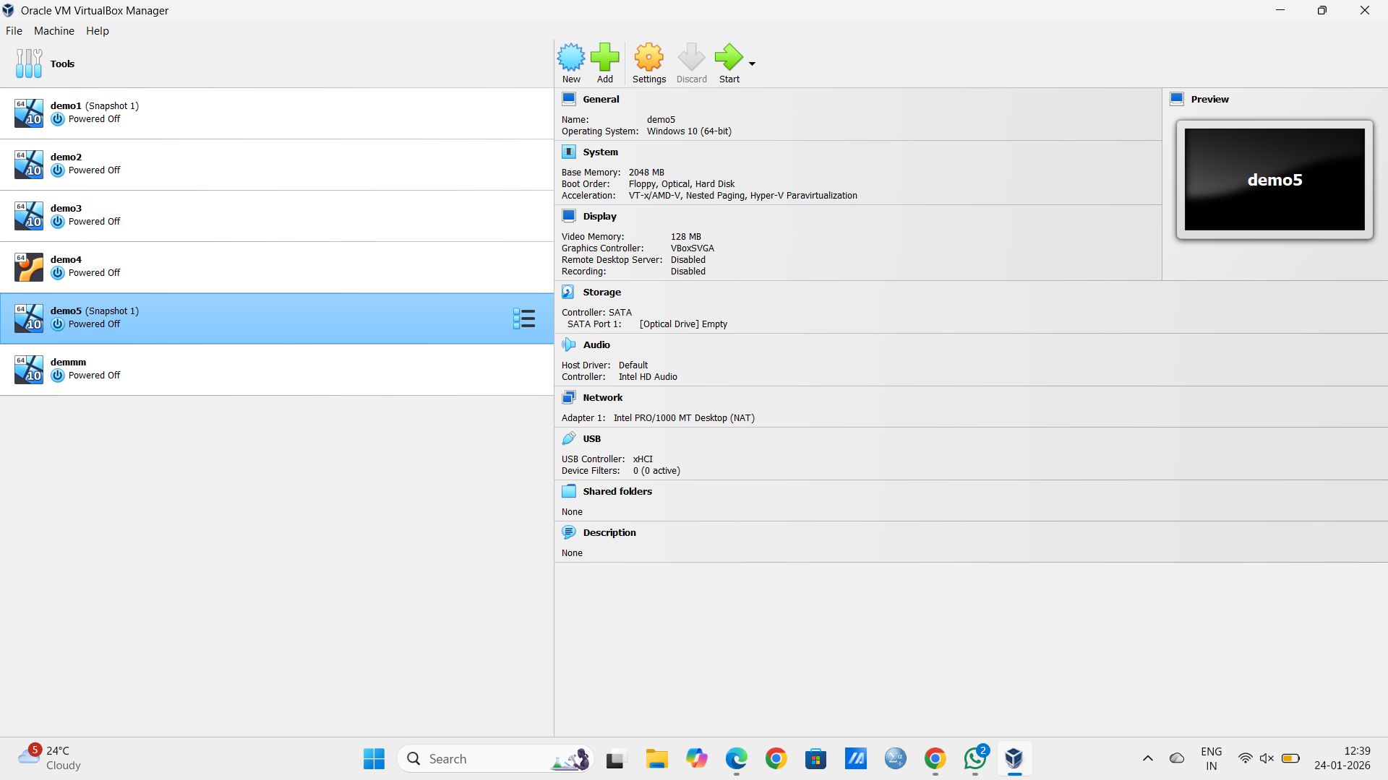

Result
The VM returns exactly to the captured snapshot state, confirming snapshot/recovery works.

